Exercises
1. Like Lumiere’s “factory workers” observe and shoot a routine event (everyday, non-distinctive activity) that reflects the environment around you or your surrounding people.
2. Discuss the fact that cinematography was first presented to the audience with documentary and not fiction.
3. How would you entitle this photo? (What title would you come up with for this photo?)
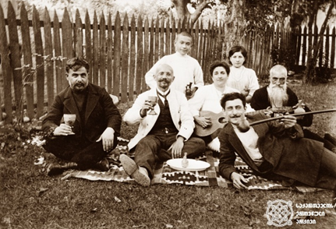
4. When two different, unconnected frames are combined together in the way, that it gives us a new meaning is called the “Kuleshov’s Effect”. Describe and give a name to the following shots according to this example.
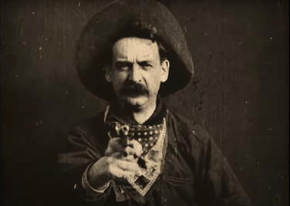 + 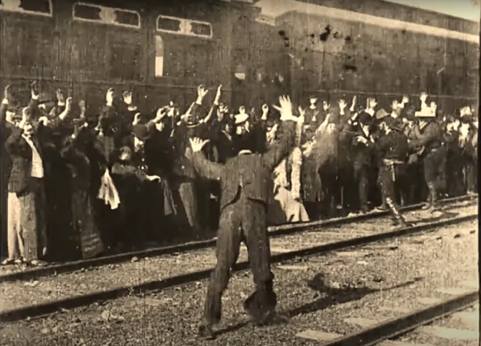 =
Frames from “The great train robbery”

5. The Lumiere brothers reflected the reality around them in the movies. What world did French director Georges Méliès bring into cinema?

6. What is traveling for you? Discuss this issue through a photo (photo from your personal archive, or internet) or through an essay (150-200 words). Were they making films in Georgia before “Akaki’s Journey”?

