Exercise:

- Try to capture your protest (it could be about household, political, personal or other issues) through a photo or video image.

2. Look up the video fragment of youth program called "Ati Atasad Zrdiloba", ("Ten Thousand Manners") which was screened on the First Channel of Georgia, (was called The State Television during 80s)
(https://www.youtube.com/watch?v=NzGpH0GU0ls) and then watch Levan Kitia's film "Trasa" ("Race Track”)
(https: // www.youtube.com / watch? v = a0KA_ekypSE). Discuss the differences between official politics and real life.

3. How would you entitle this photo?
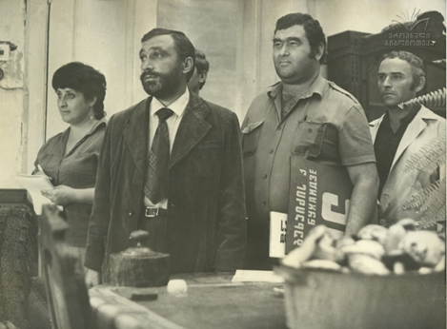

4."Kuleshov Effect" is the combination of two different, unconnected, independent frames in a way, that it acquires a new meaning. Describe and entitle a pair of shots according to this example:
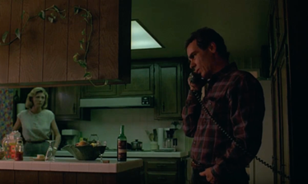 +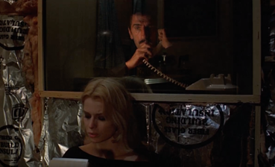=
Footage from Wim Wenders' film "Paris, Texas"

5. How do you understand the term alienation, which is becoming a common topic in Georgian cinema of this period?

6. In the 1980s, the so-called stage of nonconformism takes place in Georgian art. The new generation no longer believes in authorities and is increasingly openly confronting the system. How do you explain this step from youth? Discuss on the example of Georgian cinema of the 1980s, Write an essay (150-200 words).

