Exercises:

1. Imagine that you are the author of a documentary about the Tbilisi Civil War. Find footage, photos, etc. of this conflict on the Internet. Try to create a trailer and / or a poster for your imaginary movie.

2. Describe life that existed before and after the collapse of the Soviet Union with just two photos.

3. How would you entitle this photo?
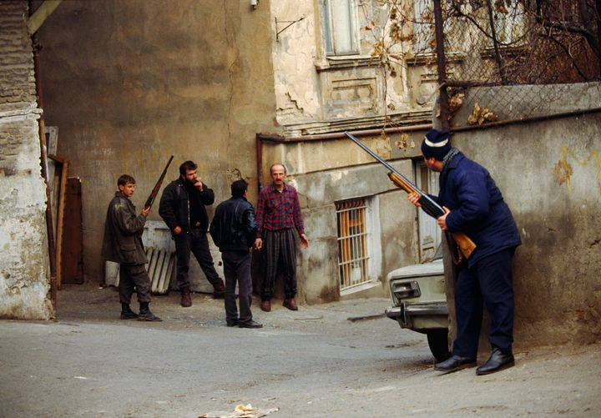

4."Kuleshov Effect" is the combination of two different, unconnected, independent frames in a way, that it acquires a new meaning. Describe and entitle a pair of shots according to this example:

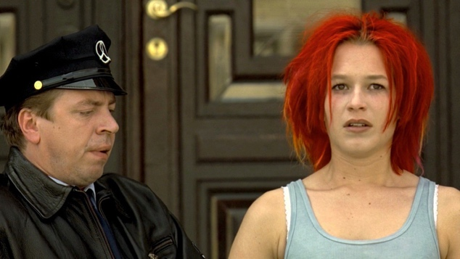+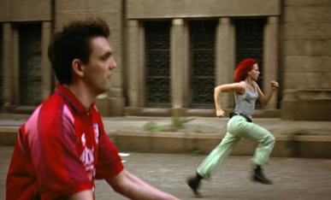=
Footage from Tom Tykwer's movie "Run, Lola, Run"

5. After the collapse of the Soviet Union, the existing official censorship was abolished. What changes are associated to the demolishing of norms and restrictions in the cinema?

6. What do you think about the civil wars, and in particular, the civil strife of Tbilisi? Write an essay (150-200 words).

