Exercises:

1. Difference between generations is an inevitable event. Compare generations of you and your parents, use visual material / photos, what changes do you think have taken place? Write down the advantages and disadvantages of each...
2. How would you entitle this photo?
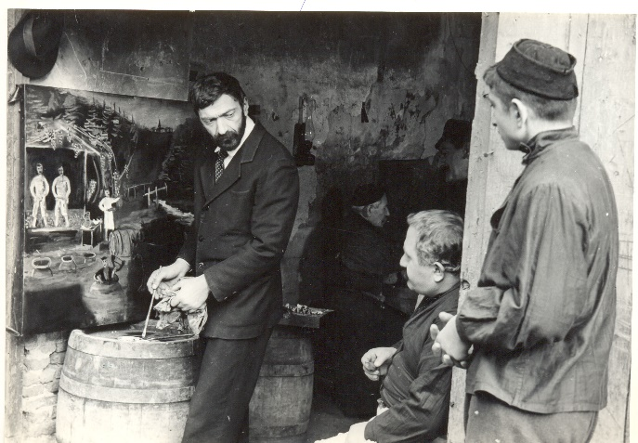

3."Kuleshov Effect" is the combination of two different, unconnected, independent frames in a way, that it acquires a new meaning. Describe and entitle a pair of shots according to this example:
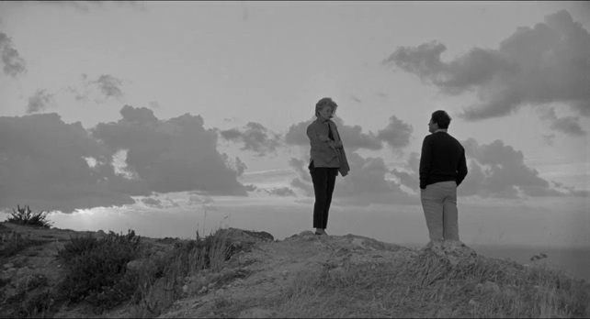
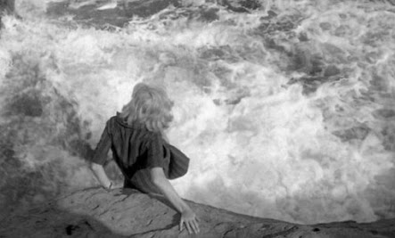
+ =
Footage from by Michelangelo Antonioni “The Adventure”

4. In the 60's there appears a "New Hero" in movies. Compare the two films "Fanfan, la Tulipe" (Fanfan la Tulipe, 1952) and "Breathless" (À bout de souffle, 1960). Describe each of them and discuss what is changing in French cinema?

5. How would you describe the conflict between "fathers and sons" in Georgian cinema? Write an essay (150-200 words).

