My Grandmother

Exercises:

- Take a photo that could be titled “My Grandmother”
- Can you recall a film with animation in it?
- Which synonyms go with the idea “My Grandmother.”
- Give the title to the photo bellow.

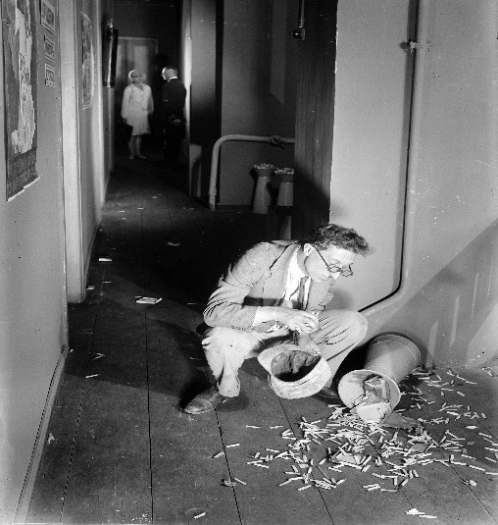

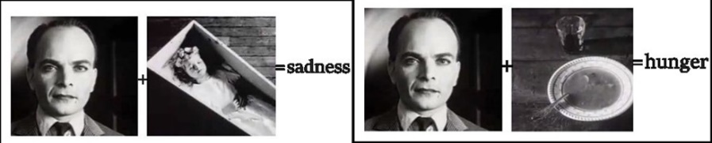
- “Kuleshov Effect” is the form of editing when two completely unlinked shots are combined to give it a new meaning.
With this example,

describe the shots bellow:

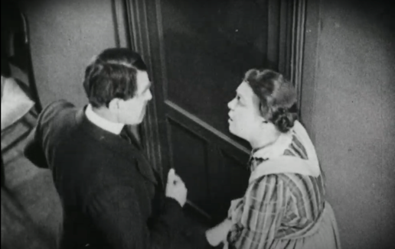
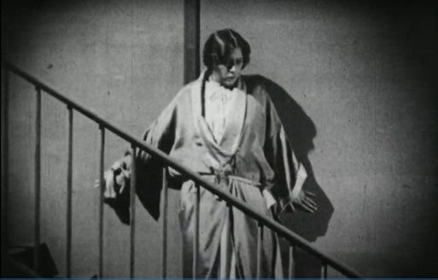

+ =

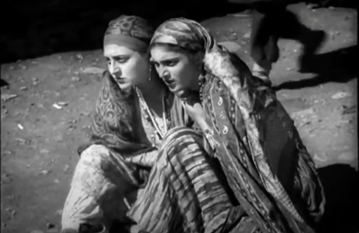
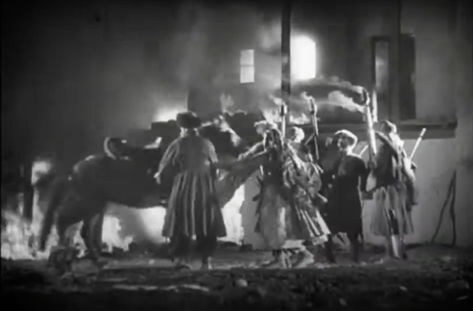

+ =

6. Give the order to the scenes to make a plot:

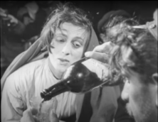
1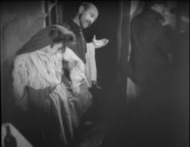 2. 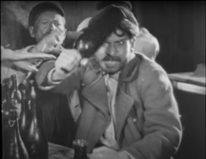 3. 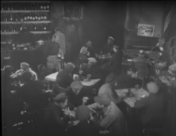

4. 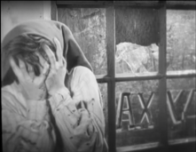 5.

7. Change the plot, epoch, location and characters of the film “My Grandmother” and write a new story (max. 150-200 words).

Questions:

- What was the title of the institution, which was responsible for the filmmaking in Georgia in 1920s.
- Name the script writer and a set designer of the film “My Grandmother.”
- Was Kote Mikaberidze entitled to participate in the restoration of the film “My Grandmother?” In case of both, positive or negative answers, please, discuss the reasons.

Quiz questions:

- Avant-garde is:
a) art oriented on innovations
b) hazardous art
c) aggressive art
d) low-quality art

2. Name the surrealistic movie by Luis Buñuel and Salvador Dali:
a) The barber of Seville
b) Temple of Barcelona
c) An Andalusian dog
d) Spanish horse

3. When was Avant-garde established in Georgia?
a) before 1925
b) after 1925
c) in 1950
d) in 1970s

4. Finish the line: Russian poetic-
a) a grotesque cinema
b) feature cinema
c) stereotyped cinema
d) editing cinema

5. Kote Mikaberidze was:
a) a director
b) an actor
c) a script writer
d) all answers are right

6. Which technique was actively established in 1920s?
a) colouring
b) sound
c) editing
d) dubbing

7. After “Sakhkinmretsv was founded, the film producing in Georgia:
a) was reduced
b) was destroyed
c) was limited
d) was Increased.

8. Which century was described in historic-revolutionary films?
a) 19th century
b) 18th century
c) 21st century
d) 16th century

9. What is the type of the film “Salt for Svanetia - Jim Shvante?”
a) feature film
b) documentary
c) documentary with feature elements
d) historical-revolutionary

10. Surrealism means conciseness released in art. Surrealistic film structure repeats:
a) a dream
b) literature
c) opera
d) poetry

11. The film “My Grandmother” is based on
a) a true story
b) original screenplay
c) famous novel from the beginning of the 20s.
d) a play by Bertolt Brecht

12. “Grandmother” means a person who uses their job to:
a) oppress the co-workers.
b) get rid of the enemies.
c) do good deeds.
d) benefit relatives.

13. The reason why the Soviet government banned “My grandmother” is:
a) too much praising of the system.
b) critic of the system.
c) anti-revolutionary plot.
d) low artistic value.

14. Kote Mikaberidze was arrested:
a) by mistake.
b) for his nervous breakdown.
c) for his confrontations with the government.
d) for avoiding taxes.

15. Expressionism is the way of manifesting one’s emotional tension in the form of art. In your opinion which of films bellow reveals expressionism?

1.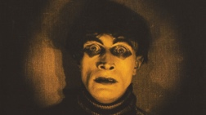 2. 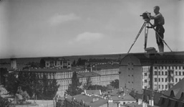 3. 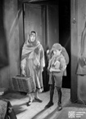

4.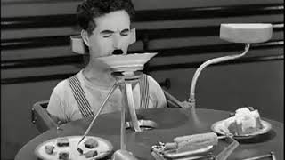

16. What were the means of storytelling in a silent movie?
a) facial expressions of actors
b) intertitles
c) editing
d) all answers are correct

17. After Sovietization (Georgia's annexation), films in Georgia were made:
a) in Russian.
b) in English
c) in Georgian-English.
d) in Georgian-Russian.

18. What does a “shelved movie” mean?
a) banned movies.
b) outdated movies
c) film tape processing
d) forgotten movies

19. Film by Nikoloz Shengelaia “Eliso” was based on the novel by a Georgian writer:
a) Vazha-Pshavela
b) Mikheil Javakhishvili
c) Alexandre Kazbegi
d) Tedo Razikashvili

20. “Jim Shvante” means:
a) good morning.
b) a dark night
c) The sun for Svanetia.
d) Salt for svanetia

Articles:

https://demo.ge/index.php?do=full&id=1486
http://gurianews.com/article/mtavari/kultura/chemi-bebia
http://www.obskura.co.uk/my-grandmother/
https://eefb.org/retrospectives/kote-mikaberidzes-my-grandmother-chemi-bebia-1929/

Recommendations:
Mikheil Tchiaureli - “Saba” (1929)
Mikheil Kalatozishvili - “Jim shvante” (1930)
Nikoloz Shengelaia - “Eliso” (1928)

