Exercises:

1. 1. The film "Christine" depicts the difficult life of women. Create a social ad that talks about protecting women’s rights. Set up an ad in the form of photos or video clips.
2. Do you agree with the opinion that cinema should strictly protect human rights?
3. How would you title this photo?

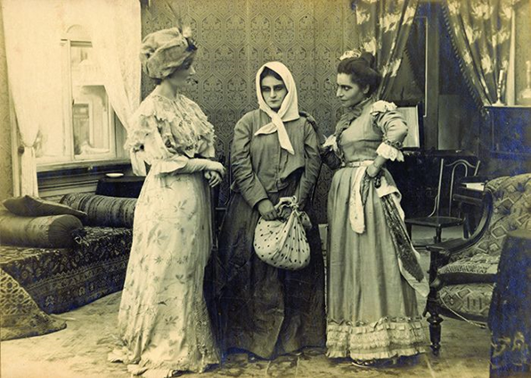

4. "Kuleshov effect" is the combination of two different, non-aligned, independent frames so that we get a new meaning. Describe and title a pair of shots according to this example:

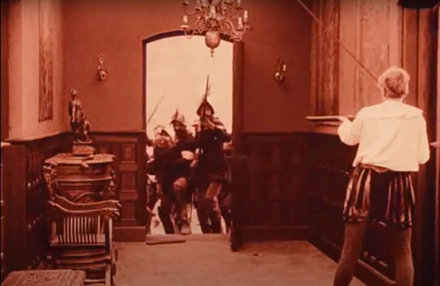 + 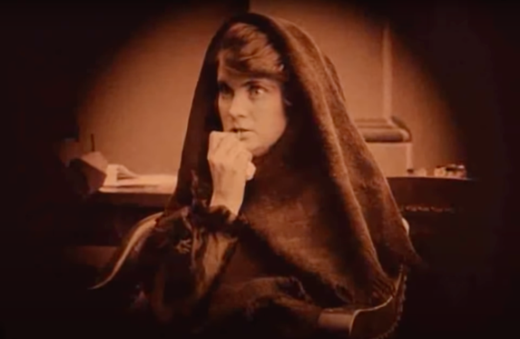 =
Episodes from the film “Intolerance”, (D.W. Griffith, 1916)

5. Editing is the grammar of cinema, which deals with the alternation, pairing and combining of different views and shots. Pair titles and shots:

A. Close up shot B. Medium (American 3/4) C. Long shot (wide shot)
1. 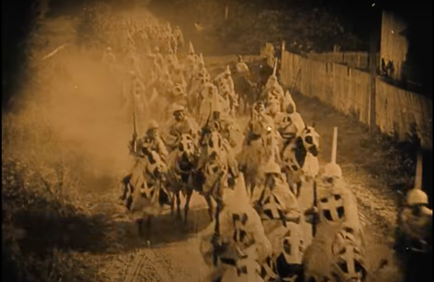 2. 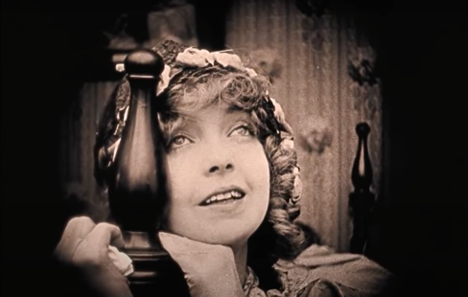
3. 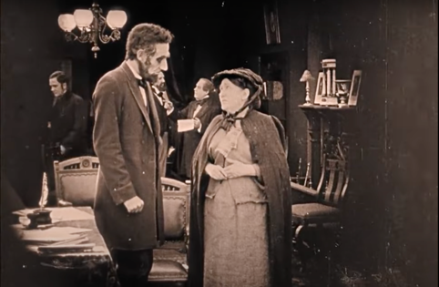
Episodes from the film “The birth of nation”, (D.W. Griffith, 1915)

6. Are all people equal? Write a short essay (150-200 words) in which you will provide arguments for universal equality.

