Dracula - 1958
In the mid-1950s cinema was in trouble thanks to the increasing spread of television and of the emergence of a younger thrill-seeking generation keen on music and hanging out in coffee bars. Similarly, horror films were in trouble too especially the kinds featuring such gothic monsters as vampires. USA-based Universal Pictures had signed an exclusive deal with Bram Stoker’s estate and by the 1940s had used and abused the character of Dracula ending up placing him in compilation films alongside the other monsters in their stable (Frankenstein’s creature and The Wolf-Man) or as cheap thrills in vehicles for comedy stars: Abbott and Costello or The Three Stooges.
All this was before the UK company Hammer films had the idea of producing their version of the Frankenstein story. It was the sensation of 1957. And out of its success grew the idea to resurrect the other great Universal horror mainstay: Dracula.
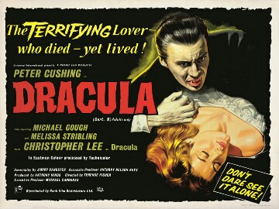
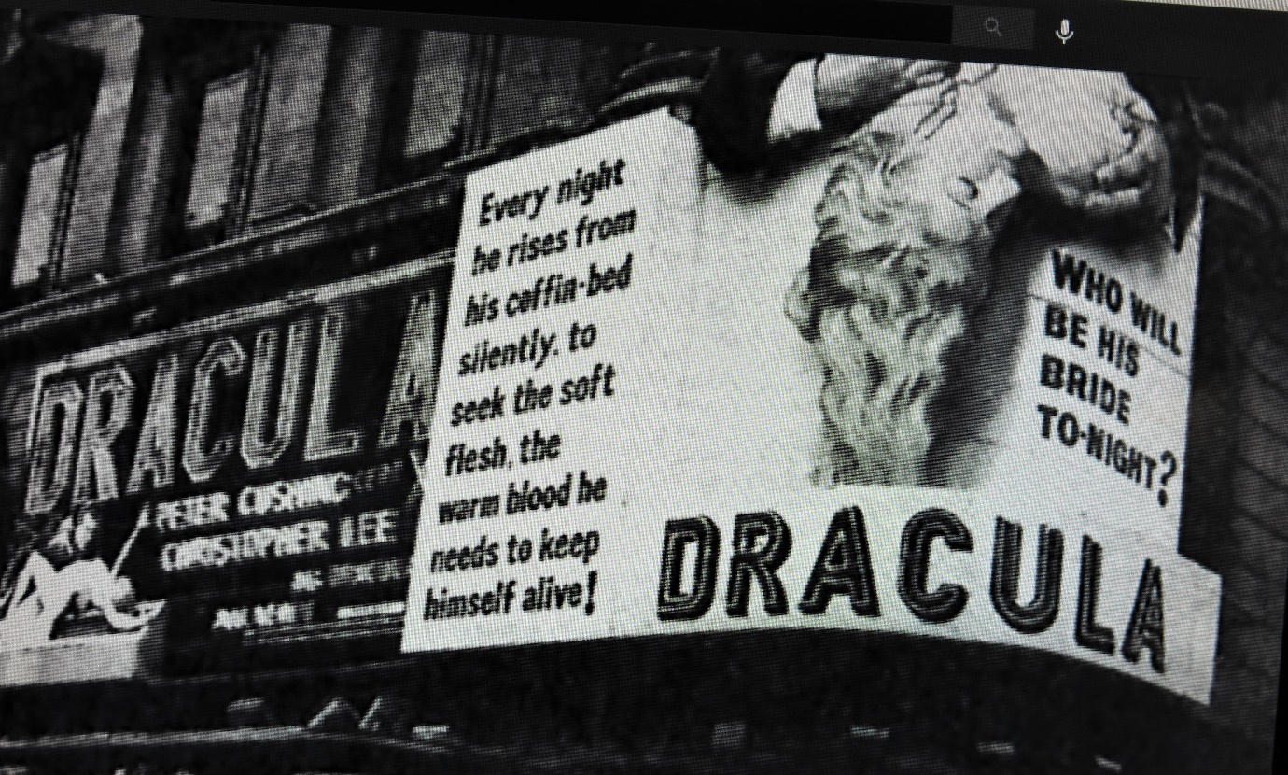
Analysing the Marketing of The film: The Poster, The Cinema Signage and The Trailer
Dracula (1958) ORIGINAL TRAILER [HD 1080p] - YouTube
Study the poster above and the photograph of actual cinema signage from 1958 and watch the trailer and try to work out how it tries to ‘place’ the film in terms of its genre and its possible audience – age/gender. You might think that The Horror of Dracula was likely to be aimed more at a male audience than female, but the trailer and the poster reveals a strong attempt to attract female viewers too. Can you suggest how?

There are lots of ways to persuade people to do or buy things. Study the following list and discuss which of the ‘hooks’ are employed in this original Horror Of Dracula trailer. Certainly, more than one applies.

- Anger
- Familiarity – a tried and tested formula or franchise; the next part of a story or series (franchise).
- The desire to be diverted or amused – escapism. The desire to explore a fantastic world or be witness to exciting events.
- Fear of missing out (FOMO)
- Watch it on a big screen in a cinema rather than via a streaming service
- Authenticity
- By-passes or pushes the rules on censorship or public taste
- Zeitgeist – what was happening in the world at the time/what people were concerned with at the time.
- Exotic locations or people
- Historic events brought to life
- A story experienced in a different context brought to life on the screen (a novel; a TV-show; a video-game; even a theme-park ride)
- Curiosity
- Endurance – this film will really put you through something.
- Empathy – understanding things from a very different point-of-view
- Romance/Love
- The sexual attractiveness of a male or female star
- The acting ability of a male or female lead
- The desire to be horrified or shocked
- Education – you’ll learn something by seeing this film.
- Soundtrack/Music

Anything else?

Why The Time Was Ripe For The Horror of Dracula in 1958.
The following list sets out some possible reasons why, Hammer chose to make a film of Dracula and/or had such success with it. The film cost just £81,000 and made over £3 million in cinema seat sales.
There are no right or wrong answers here – all you have to do is decide which order these suggestions should be in from most significant to least. You could share out these suggestions with classmates and create ‘a physical priority line’ which will involve some negotiation and discussion.
You can take these ideas one stage further, and using your ‘priority’ discussions turn this into a detailed essay about the importance of the 1958 film and the reasons for its impact.
- There is something about vampires that is compelling. Anne Billson writes: ‘Traditionally, the vampire casts no reflection, but instead it reflects us; each generation sees in the vampire what it fears or desires, or fears and desires, for they ae often the same thing. Christopher Lee’s Dracula could thus be the bloodsucking older generation monster feeding on the lifeblood of a younger generation, or a compelling sexual liberteen liberating those (women) he feeds on from the shackles of convention and repression. Take your pick.
- The Hammer vampire in Horror of Dracula catered brilliantly to the new adolescent audiences in emphasising the sexual content of Bram Stoker’s original tale, and in particular a kind of sanitised and unemotional sex that was at once both erotic but also curiously ‘safe’. As the scholar James Twitchell writes in ‘The Living Dead – a Study of the Vampire in Romantic Fiction’ (1981) of sex in vampire fiction: ‘It is sex without genitalia, sex without confusion, sex without responsibility, sex without guilt, sex without love – better yet: sex without mention.’ (Source: Christopher Frayling – Nightmare: The Birth of Horror. BBC Books 1996)
- There is something about vampires that makes them more attractive than other fictional nightmare creatures. ‘They are a superior kind of monster,’ writes Anne Billson in the Bfi’s Gothic: The Dark Heart of Film (2013), ‘sexier than the zombie, more cunning than Frankenstein’s monster, less hapless than the Wolf Man, better dressed than the Mummy…. As the years have gone by <vampires> are seen not just as powerful, intelligent, charismatic individuals but more sympathetic, perhaps as a result of an erosion in rigid moral standards… as well as the appeal of the rebel outsider, the rise of the conflicted anti-hero and the enshrinement of the wishes of the individual over the needs of society.’
- During the early 50s Hammer had great success with several Science Fiction films, some (The Quatermass Experiment (1954) and Quatermass 2 (1956) adapted from TV series, but by 1958 the genre had started to run out of steam and something more sensational was needed.
- The film is ambiguous when it comes to the play of good and evil. There is more than a little fanaticism about Peter Cushing’s Van Helsing, and the sense that his efforts to destroy Dracula’s victims has less to do with restoring their innocence than quelling their new-found sexual agency, undermines his moral project.
- By the mid-50s more and more families were acquiring televisions, and this began the steady decline in cinema-going. In order to win over the new youth audience, Hammer recognised that more sensational and ‘strong’ content was required.
- The Horror of Dracula came out as Britain still recovered from the Suez Crisis that had exposed the limitations of the ‘establishment’. At the same time, youth culture was taking off with the new post-war generation enjoying greater financial independence and the consumerism that went with it.
- To quote Jonathan Rigby in English Gothic: classic horror cinema 1897-2015 (Signum Books, 2015): ‘The ultimate consumer, Christopher Lee’s young and ruthless vampire – with a steady string of undead mistresses and a conspicuously well-appointed castle - would provide just as twisted a reflection of the burgeoning consumer society as had Cushing’s amoral Frankenstein; indeed, several commentators have pointed to Cushing and Lee as Gothic progenitors of Sean Connery’s James Bond.’ (Page 66.)
- The success of Horror of Dracula is largely down to Christopher Lee’s compelling performance. He is only on screen for seven minutes and speaks just 16 lines, but he captured something of the Bram Stoker original character: both sophisticated but also capable of wild violence and feral ferocity. He was also a very tall man and this too leant his characterisation great authority. The role of Dracula would make him a star but it would also, he claimed, prove a bit of a curse. Lee was forever claiming he had played the part for the last time only to return in Hammer sequel after sequel during the 1960s and 70s. Lee’s portrayal was so strong perhaps because he respected the character and saw in Dracula ‘the terrible solitude of evil’.
- Peter Cushing as Doctor Van Helsing is also another major factor in the Horror of Dracula’s success. Cushing was an award-winning actor and he had already formed a partnership with Christopher Lee in the Curse of Frankenstein. To quote Jonathan Rigby’s English Gothic (Signum Books 2015): ‘Both men would become indelibly associated with the British horror film, and their consistently elegant and intelligent performances would do much to elevate the form to a position where it commanded international attention.
- The film benefited from a screenplay that cut out huge portions of the Bram Stoker original tale. The motivation may have been financial, but the impact was tangible, speeding up the drama. The introduction of a seeming hero in the form of John Van Eyssen’s Jonathan Harker at the start of the film and then having him succumb to Dracula and then later killed, anticipates, some critics suggest, Alfred Hitchcock’s 1960 chiller Psycho in which the same narrative game-playing occurs
- The final confrontation between Van Helsing and Dracula is highly ‘swashbuckling’ (to quote the critic Kim Newman). It is a strikingly violent scene and the ’final defeat and disintegration of the vampire was considered so shocking that the censors (the BBFC) demanded the removal of certain shots – only recently restored.
- The Horror of Dracula in 1958 coincides and reflects the emerging youth culture of the end of that decade. Post-war rationing was now over and the ‘never had it so good’ rock and roll generation of young people were coming of age, with disposable incomes and an irreverent attitude to old moral principles: all fertile ground for the kind of lurid, sensational thrills Hammer started to offer.
- Hammer Films was started in the 1930s by William Hinds and Enrique Carreras – the latter recently bankrupted by a failed business venture involving toothpaste. Carreras’ son James soon joined the fold. By the 1950s the company enjoyed major success with horror thanks to the Curse of Frankenstein and gained an American financial and film distribution partner in United Artists. This formula would be repeated for Horror of Dracula, though for this film it was Universal that Hammer partnered with, gaining access to a significant back-catalogue of horror stories ready for modern telling.
- There is much in Horror of Dracula that is defiance in the face of the critics who had complained so loudly about The Curse of Frankenstein. The early moment when blood gratuitously spills onto a stone carving of ‘Dracula’ is seen by some as a gigantic ‘up-yours’ to the commentators who condemned the earlier film because of its lurid blood-letting.

Filming Dracula
The following table defines a number of the key shots that filmmakers can use to create meaning in a movie. The goal is to match the shot type to the occasion in “Dracula” that they would best suit. There are more moments than shot types because it is important to recognise that there is no shot has a single meaning or a single usage.

Shot type | Dracula Moment
- Extreme long shot: This is used for views of landscapes or buildings. It might also be the point of view of a character looking out over a vista.  - Long Shot: A character is shown at some distance. They will be dominated by their surroundings.  - A Medium shot – also known as a mid-shot. In this kind of shot a character is shown from the waist upwards. The audience will be able to see their reactions but the background surroundings will also be prominent in the shot. When two characters are shown together in mid-shot it is sometimes called a ‘two shot’.  - A close up. A shot of a person’s head and shoulders. Not much, if any, background detail appears in the frame. The shot to use when wanting to catch a character’s emotional response to something or when they are communicating their thoughts.  - An extreme close up. This is used to show an important detail, object, gesture or moment of contact between characters.  - A high angle shot. This is used to communicate the idea that someone is being watched from above or is alone. It usually (but not always) makes characters seem less important.  - The most extreme form of high angle shot is a ‘bird’s eye’ shot, taken directly above someone.  - A low angle shot. The ideal shot to make someone seem larger than life or to suggest we are seeing someone through the eyes of someone seated or smaller than them – a child looking up to an adult. | a. This shot would suit the moment when Jonathan Harker looks out of the window of his bedroom in Castle Dracula to see the Count far below scaling the walls of the edifice like an animal.  b. The ideal shot for suggesting a character wandering through the woods is being overlooked prior to a vampire’s attack.  c. Harker busy picking up a plate from the floor, realizes he is not alone, and glancing up is amazed to see a beautiful young woman gazing down at him. She has entered silently – her footfalls having made no noise.  d. This is kind of shot with which to show the mountains of Carpathia - Dracula’s native land. It would suggest the huge distances Jonathan Harker has travelled and how far from home he is.  e. This might be the sort of shot to use to show Jonathan Harker as he stands before the cliff-like walls of Castle Dracula having arrived on foot or perhaps after a wild carriage ride. He is a tiny figure and the castle towers over him  f. The perfect shot to show the slowly opening coffin containing Dracula. As the lid is pushed back a claw-like hand emerges.  g. A shot for communicating very detailed information. It might be used to show the contents of a letter a character is reading or items taken from a vampire-hunter’s bag. Or perhaps the portrait of Harker’s fiancé  h. A shot for showing a character experiencing a moment of strong emotion for example, Harker’s horror at realizing the young woman he is embracing is attempting to bite his neck, or Dracula’s fury.  i. Dracula’s perspective as he moves in on a female victim.  j. This shot would be ideal for showing vampire-hunter Van Helsing driving with a silver cross the undead Lucy Holmwood away from her brother who she was about to bite. In addition to the group, this shot shows us the eerie graveyard setting.

Film making - Collaboration

It is important to remember that film making is a collaborative exercise. Many different people are involved in creating the finished film that we see on the screen.

Your task is to read the extract of the novel below and then highlight sections of the story where the following members of the film making team would need to be involved:

The set designer
The props department
The actors playing Harker and Dracula .

Code the passage with CU (close up); MS (Medium Shot); LS (Long Shot); HA (High Angle); and LA (Low Angle) to show how the cinematographer might set up his camera to catch elements of this description. Would you film it, perhaps all from Oliver’s point-of-view (p-o-v)

Also – can you think of any places in the sequence when the director might ask for a special camera movement of some sort, a movement perhaps that adds to our sense of Harkers’s smallness or isolation or his fear or Dracula’s control of the situation or animal-like power or supernatural strength?

And finally, where might you want to use music in this sequence?

When the calèche* stopped, the driver jumped down and held out his hand to assist me to alight. Again I could not but notice his prodigious strength. His hand actually seemed like a steel vice that could have crushed mine if he had chosen. Then he took out my traps, and placed them on the ground beside me as I stood close to a great door, old and studded with large iron nails, and set in a projecting doorway of massive stone. I could see even in the dim light that the stone was massively carved, but that the carving had been much worn by time and weather. As I stood, the driver jumped again into his seat and shook the reins; the horses started forward, and trap and all disappeared down one of the dark openings.
I stood in silence where I was, for I did not know what to do. Of bell or knocker there was no sign; through these frowning walls and dark window openings it was not likely that my voice could penetrate. The time I waited seemed endless, and I felt doubts and fears crowding upon me. What sort of place had I come to, and among what kind of people? What sort of grim adventure was it on which I had embarked? Was this a customary incident in the life of a solicitor’s clerk sent out to explain the purchase of a London estate to a foreigner? Solicitor’s clerk! Mina^ would not like that. Solicitor—for just before leaving London I got word that my examination was successful; and I am now a full-blown solicitor! I began to rub my eyes and pinch myself to see if I were awake. It all seemed like a horrible nightmare to me, and I expected that I should suddenly awake, and find myself at home, with the dawn struggling in through the windows, as I had now and again felt in the morning after a day of overwork. But my flesh answered the pinching test, and my eyes were not to be deceived. I was indeed awake and among the Carpathians. All I could do now was to be patient, and to wait the coming of the morning.
Just as I had come to this conclusion I heard a heavy step approaching behind the great door, and saw through the chinks the gleam of a coming light. Then there was the sound of rattling chains and the clanking of massive bolts drawn back. A key was turned with the loud grating noise of long disuse, and the great door swung back.
Within, stood a tall old man, clean shaven save for a long white moustache, and clad in black from head to foot, without a single speck of colour about him anywhere. He held in his hand an antique silver lamp, in which the flame burned without chimney or globe of any kind, throwing long quivering shadows as it flickered in the draught of the open door. The old man motioned me in with his right hand with a courtly gesture, saying in excellent English, but with a strange intonation:—
“Welcome to my house! Enter freely and of your own will!” He made no motion of stepping to meet me, but stood like a statue, as though his gesture of welcome had fixed him into stone. The instant, however, that I had stepped over the threshold, he moved impulsively forward, and holding out his hand grasped mine with a strength which made me wince, an effect which was not lessened by the fact that it seemed as cold as ice—more like the hand of a dead than a living man. Again he said:—
“Welcome to my house. Come freely. Go safely; and leave something of the happiness you bring!” The strength of the handshake was so much akin to that which I had noticed in the driver, whose face I had not seen, that for a moment I doubted if it were not the same person to whom I was speaking; so to make sure, I said interrogatively:—
“Count Dracula?” He bowed in a courtly way as he replied:—
“I am Dracula; and I bid you welcome, Mr. Harker, to my house. Come in; the night air is chill, and you must need to eat and rest.” As he was speaking, he put the lamp on a bracket on the wall, and stepping out, took my luggage; he had carried it in before I could forestall him. I protested but he insisted:—
“Nay, sir, you are my guest. It is late, and my people are not available. Let me see to your comfort myself.” He insisted on carrying my traps along the passage, and then up a great winding stair, and along another great passage, on whose stone floor our steps rang heavily. At the end of this he threw open a heavy door, and I rejoiced to see within a well-lit room in which a table was spread for supper, and on whose mighty hearth a great fire of logs, freshly replenished, flamed and flared.
Bram Stoker: Dracula (Chapter 2)
The Project Gutenberg eBook of Dracula, by Bram Stoker
*(a light, horse drawn carriage)
^Mina: Jonathan Harker’s fiancé back in England

Music by James Bernard
The musical soundtrack for The Horror of Dracula is deservedly famous: one of the most effective that James Bernard ever composed for Hammer – and he composed music for 24 films for the studio over 18 years. In particular, it is the three chord signature which actually echoes the word’ Dracula’ that is particularly memorable. You can listen to a compilation of all the music from the film at: James Bernard - The Horror of Dracula - From "The Horror of Dracula Original Soundtrack - YouTube
There are a number of changes in tempo and mood during the 14-minute file. As you listen to it consider what sequences you might marry up with the separate ‘sections’ – for example, arrival at the castle, the pity and horror of saving Lucy from vampirism, Dracula revealed… etc. You can give each of the sections a title, perhaps, or attempt to write a description of the possible events accompanying the music at any given moment and then check when you see the film to see if your choices match those of the film-makers/sound-editors.
James Bernard | Film | The Guardian

Censorship
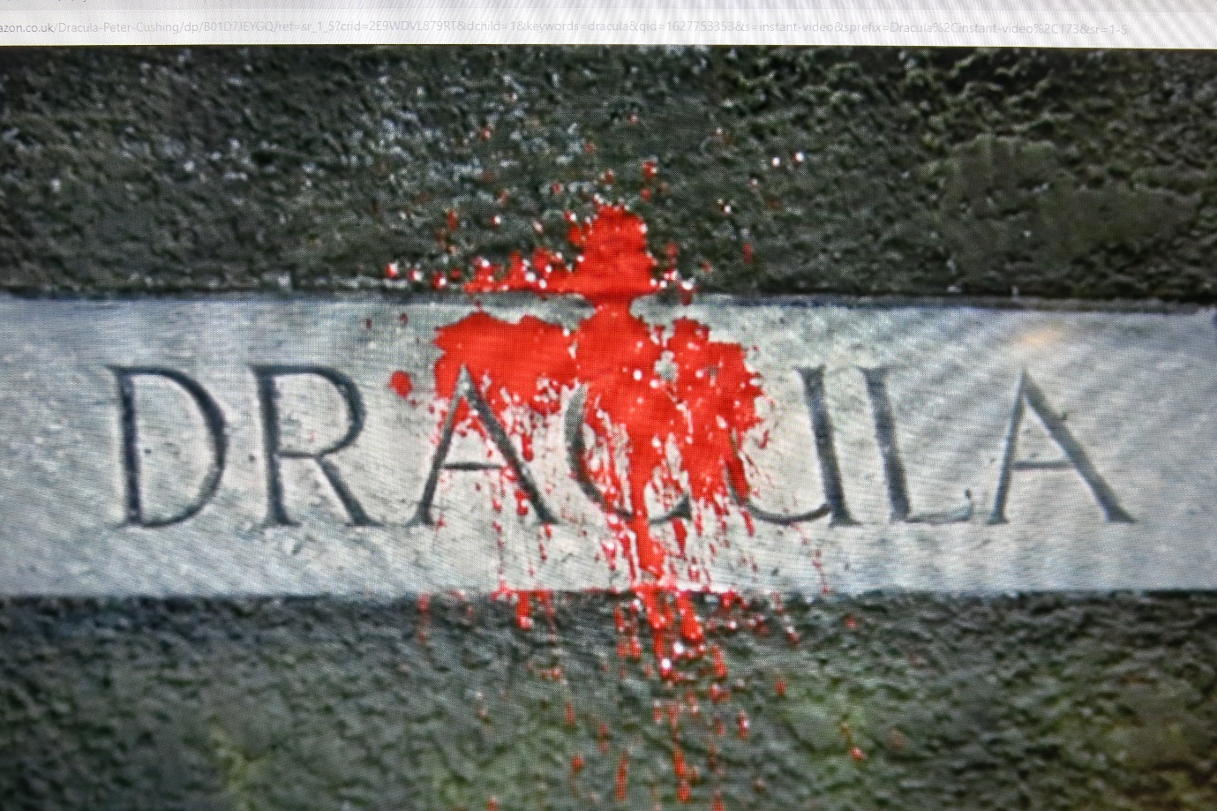We live in an age where censorship (other than the 9.00pm TV watershed) has more-or-less ceased to exist. Thanks to the internet and social network streaming sites, there is almost nothing of a sexual or violent nature that can’t be accessed, and mainstream film and television while still constrained, is certainly more unbridled in its content than at almost any time. It is hard therefore, to imagine that The Horrors of Dracula once represented a huge leap in terms of what was permitted to be shown and had to jump through all sorts of hoops to get past the British Board of Film Censors (BBFC).
There is evidence to suggest that considerable negotiations went on between the BBFC and Hammer, with the filmmakers including some quite (for then) extreme sequences which they were content to lose, in order that the censors would allow them other moments of horror or gore that were less explicit.
Today, it is possible to see an uncensored version of the film thanks to a restoration process that re-introduced certain sequences, such as the women’s evident glee and pleasure during their encounters with Dracula and the final disintegration scene which was originally deemed too grim for public viewing.
Here is one of the summative comments of the BBFC censor about the film:
‘The uncouth, uneducated, disgusting and vulgar style of Mr Jimmy Sangster cannot quite obscure the remnants of a good horror story, though they do give one the gravest misgivings about treatment.. I never red the original story and do not remember the first film , though I know it had a great effect on me when I saw it at the age of 18 or thereabouts. It seems to me that there is nothing censorable in the story as a whole, but a good deal to complain of in details. The curse of the thing is technicolour blood: why need vampires be messier feeders than anyone else? Certainly strong cautions will be necessary on shots of blood. And of course, some of the stake-work is prohibitive.”
Your task is to try to be the BBFC censor of the time. Using the passage above as your lead as to what to look out for, take a sequence from any point in the film and write notes to the filmmakers expressing your detailed disapproval of anything you feel is objectionable and likely to ‘harm’ viewers. You can also praise anything you feel is suitably restrained.
As a follow up exercise read Paul Frith’s interesting account of censorship as it affected Hammer Films in the period 1957-1962 in the Historical Journal Of Film , Radio and Television (Vol 39, 2019 – Issue 2) Full article: ‘The curse of the thing is Technicolor blood: why need vampires be messier feeders than anyone else?’: The BBFC and Hammer’s Colour Films, 1957–1962’ (tandfonline.com)
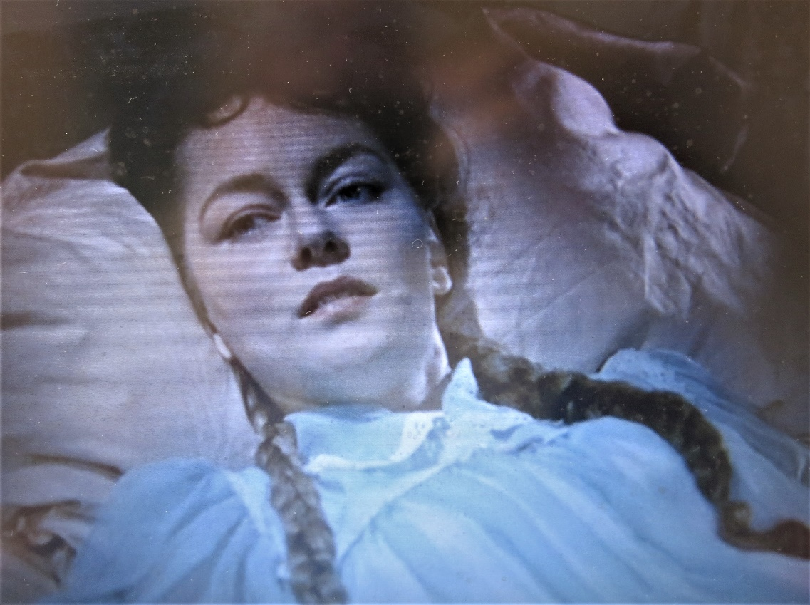
The look of love: Carol Marsh (Lucy Holmwood) gazes in eager anticipation as Dracula approaches her bed.
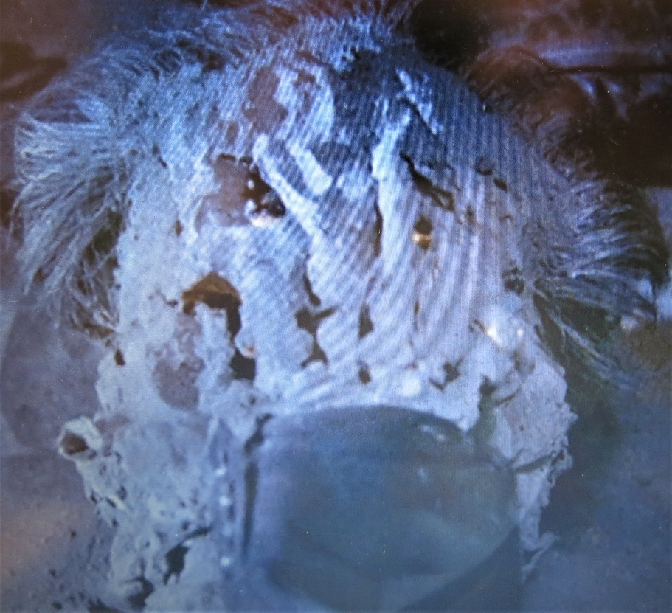
Dracula’s final end – or is it? The graphic depiction of the Count’s disintegrating face gave the BBFC some problems and they demanded cuts – only recently restored.

