Blackmail
“Hitchcock….. is the most complete filmmaker of all. He is not merely an expert at some specific aspect of cinema, but an all-round specialist, who excels at every image, each shot, and every scene. He masterminds the construction of the screenplay as well as the photography, the cutting, and the sound-track, has creative ideas on everything, and can handle anything, and is even, as we already know, expert at publicity.” (From ‘Hitchcock’ by Francois Truffaut - English edition: Secker & Warburg 1968)

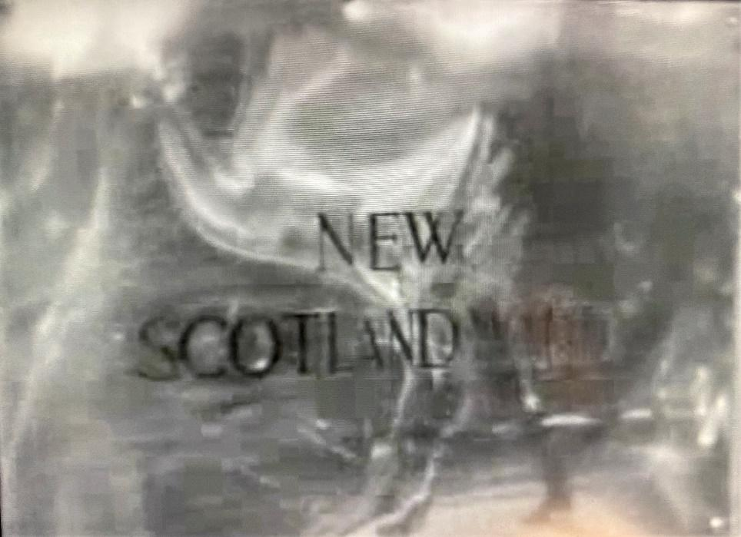 (05.36 and 1.18.26)
There are two occasions in Alfred Hitchcock’s 1929 film Blackmail when this name plate appears. It helps to signpost where we are and the next interior scenes, we assume, are located inside the offices of London’s principal police station. But there is an ambiguity here too? As this resource will explore, Hitchcock was not a ‘spontaneous’ director, free-spirited with his camera and hopeful of capturing some magic by chance. He was a meticulous planner: even to the extent, famously, of finding filming a bit of a bore given that much of the creative work in mapping out and story-boarding his stories had already been done in advance. In keeping with this is his famous dictum that actors should be treated ‘like cattle’.
So, given that this was Hitchcock’s way of making films, it is reasonable to wonder why he chose to include shots of The Scotland Yard sign that were so distorted, clouded, and smeared. In these shots we can see the outlines of people passing by, but they are mere outlines. Shadows. What do you think this might suggest?
- The power of this institution.
- The ambiguous relationship of this institution and people’s lives: capable of reaching out to touch one of these individuals passing in the street, with potentially irrevocable consequences.
- The idea that the institution is itself not entirely bright and shiny, but a bit smeared and clouded itself. Is the justice it dispenses unambiguously ‘correct’?

Activity 1: Crime
If there is one thread that joins most of Hitchcock’s films, it is ‘crime’. Hitchcock was fascinated by crime and murder. In an essay titled ‘Murder’ - one of a collection of monographs about the director published by the British Film Institute in 2012 called ’39 Steps To The Genius of Hitchcock’) Graham Fuller points out Hitchcock’s knowledge of the 19th Century writer Thomas de Quincey. In one of his essays of 1827 De Quincey speaks of the ‘best’ murders requiring far more than ‘two blockheads to kill and be killed’ but instead ‘design, light and shade, poetry, <and> sentiment…” Fuller feels these qualities are present in the best depictions of murder in Hitchcock’s films.

Here are a few aspects of the murder and the scenes immediately leading up to it (and away from it) for you to consider – all of which suggest Hitchcock’s artistic mastery; his control of ‘design, light and shade, poetry and sentiment…” While the script is important, it is mainly the images that prove most suggestive, so:

- Stairs

Compare the treatment of the staircase in the Artist’s lodging house. Notice the long time it takes Alice and the Artist to mount the stairs? How does this add to the suspense? Notice how shadows on the way up are used to suggest what – barriers? a trap? prison bars?

Then look at how Hitchcock films the stairs as (the now) murderer Alice prepares to descend. It is the first part of a long sequence in which Alice finds herself in a changed threatening world because of her altered moral status – no longer the nice respectable daughter of a shopkeeper in the King Road, but a killer with blood on her hands.
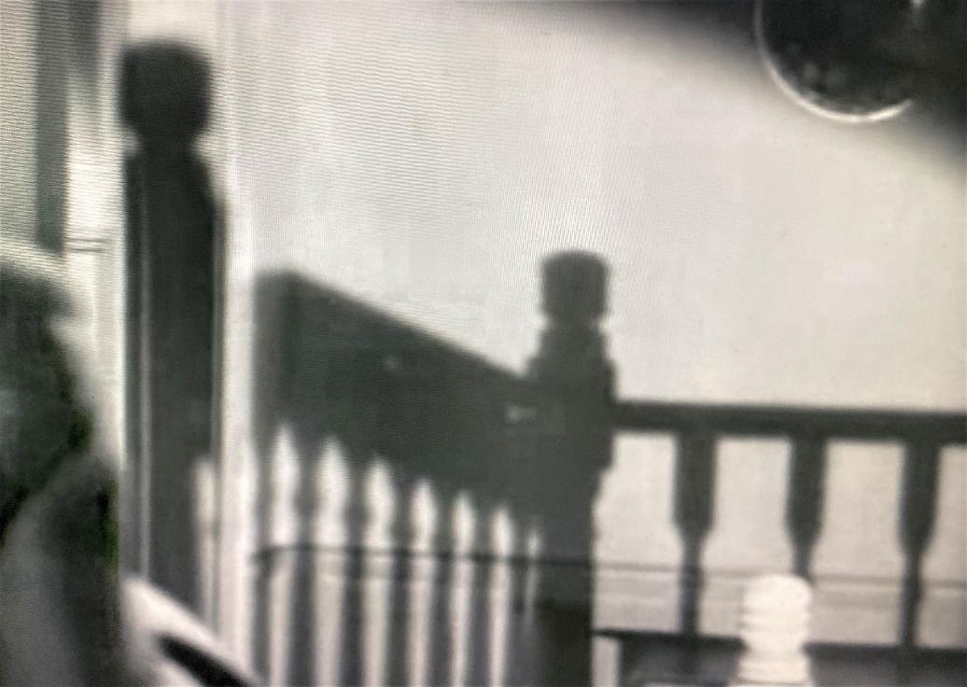

Going up.(21.15)

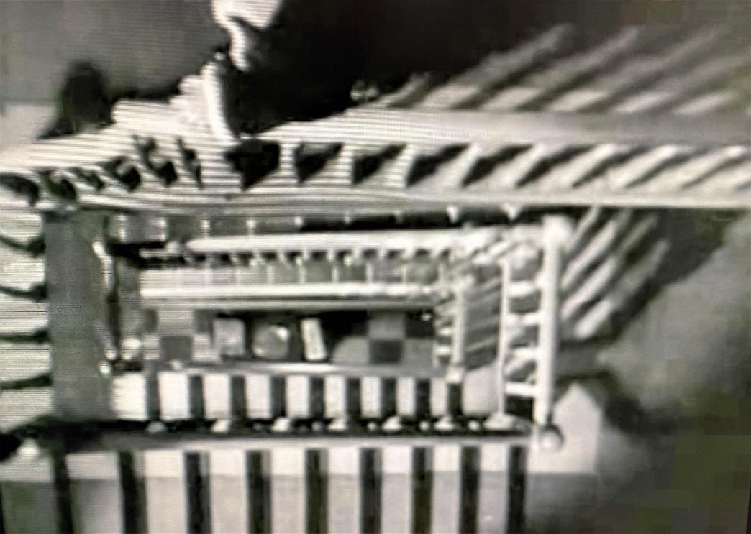

Coming down (37.02)

- Voyeurs
Hitchcock often put his heroines in danger. He is on record discussing the sorts of women he chose to play leading parts in his films and some of the indignities he subjected them to, both on and off-screen would not be acceptable today. It is also much more problematic, these days, depicting sexual violence and Blackmail is not alone among Hitchcock’s films in putting the viewer in a very voyeuristic position – sometimes even in the shoes of predators. This is particularly the case in the murder scene where we are given a ring-side seat to what happens. Take, for example, this shot of Anny Ondra as Alice White dressing behind the screen. It may protect her from being ogled by the Artist, but not from the audience. What is your reaction to this shot? It is not a short sequence – we watch the actress undressing for over a minute and then later we witness her undressing again when she tries to get back into her ordinary clothes. Discuss the difference it may be to be a male or female audience-member at this point.
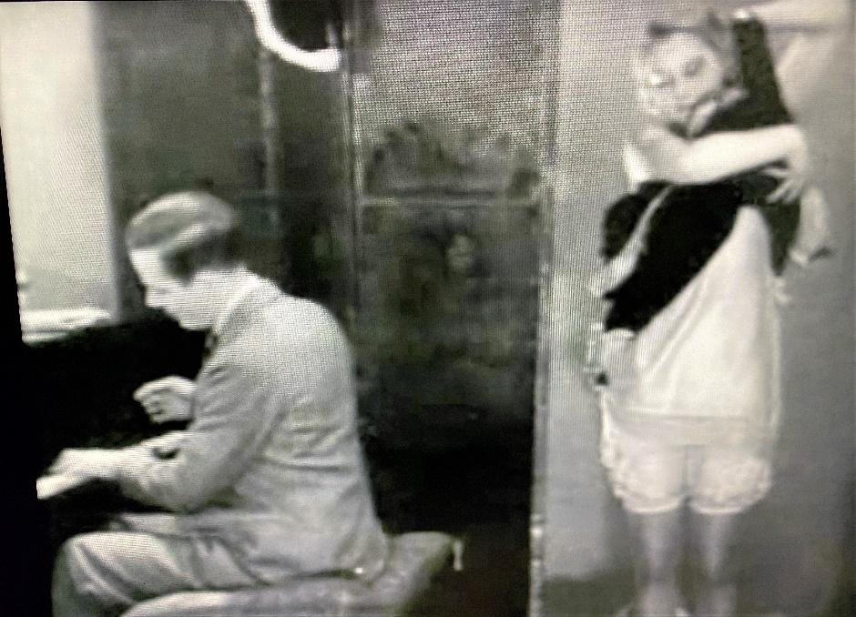 28.00-29.00
C. Creating Suspense
Hitchcock is a master of suspense. In a film in which police-work and procedures are prominent, it is also interesting to see how Alice attempts to cover up her crime. Study the moments in the immediate aftermath of the stabbing and note the measures that Alice takes to avoid detection. But all the while, there is a massive clue that she may or may not remember to remove: her signature on the picture. As with so much in this film, and all Hitchcock’s movies, nothing is innocent and usually the simplest of incidents have different functions depending on how the narrative develops.
What, for example, is suggested by the seemingly playful incident when Alice early in her visit to the studio paints her face and the artist adds a naked body to it? During your first viewing of the scene, try to remember if you forget about the signature or is it always on your mind? What, if anything, do you think is symbolic about Alice rubbing out her identity – leaving a black blob?
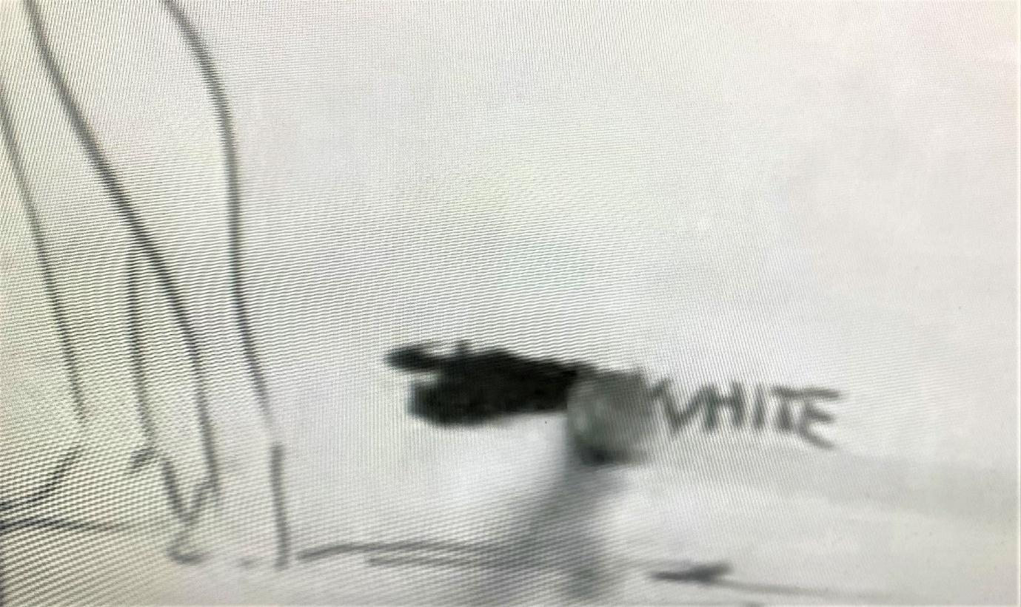
(36.38)
D. The Mask and The Mirror
The artist’s flat, at the top of a long flight of stairs, filled with costumes, a mask, and large canvases that look like theatrical backdrops, has the air of a lumber room of the unconscious, a place where suppressed impulses irrupt far away from societal restraints. (Source: Hitchcock’s ‘Blackmail’ and the Birth of the British Talkies | PopMatters)
On entering the attic studio there is a very intriguing shot of both the Artist and Alice standing with a mask on the wall behind. With Hitchcock – perhaps more than any director - nothing that appears in a frame is accidental, so it is right to assume this configuration means something. It is interesting that the mask hovers over Alice. Discuss the significance of ‘masks’ and how different characters at different stages of the film – especially Alice - end up emotionally behind masks one way or another.
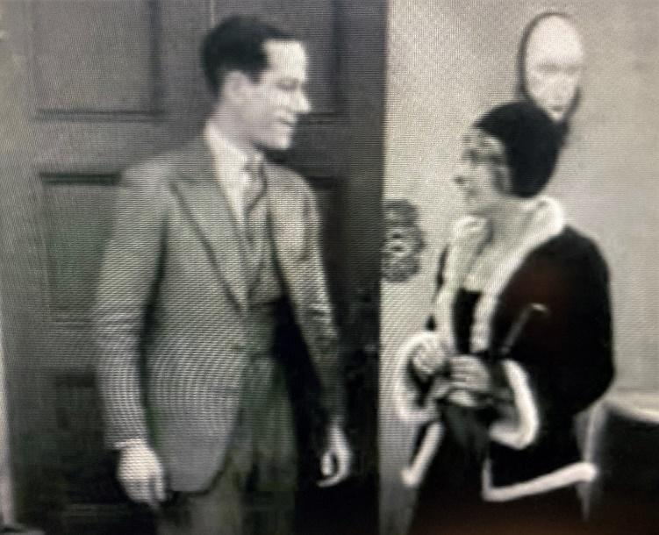 (21.28)
Notice, also, what has the capacity to penetrate Alice’s mask after the crime: consider the portrait of the Jester and Hitchcock’s amazing use of sound in the breakfast scene – something that we will return to in another activity.
Mirrors are also an important motif in this film and in Hitchcock’s broader film-making repertoire. Consider what it might mean to have two images of a character on the screen at the same time: a double.
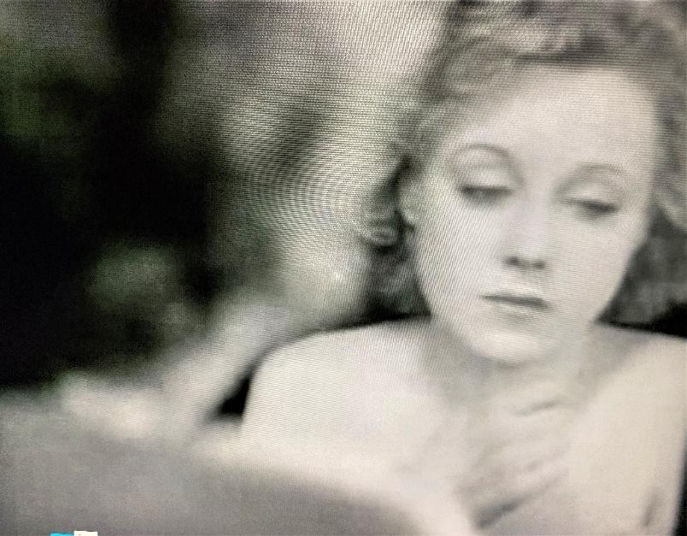 (45.09)

E. The City of Guilt and Fear
After the killing, Alice walks the streets of London in a daze. Being back in among ordinary people and ordinary activities brings her no relief: quite the opposite. The following list may not be complete so do add to it. Meanwhile, your task is to assess how the following reflect Alice’s guilt and/or her increasingly paranoid state of mind:
- Her furtive departure from the Artist’s lodging house and the shadows she throws up onto the walls as she leaves.
- Notice how out of phase she is compared to the other pedestrians that keep passing her at speed.
- Notice her reaction to the traffic policeman. What is it about him that she fixates on?
- What is ironic about Alice’s encounter with the theatre crowd just emerging from a play?
- Look for any ironies in the neon signs she observes before the hallucination that turns the cocktail shaker into a dagger.
- Another hand, this time the tramp’s: what do you make of this detail?

Activity 2: Sound
Blackmail was not the first British ‘talkie’ but it was the first really successful British talking picture both in the UK and worldwide. In all the literature about the film, special mention is made of the famous ‘breakfast’ scene where the word ‘knife’ becomes more and more prominent – reflecting Alice’s guilt and fear. Can you think of other occasions when adjusting the sound in this way might be used to reflect a character’s mental state? For example, someone in love.
This is far from an full list – so do please note other moments when sound is used by Hitchcock to powerful or clever effect - not least now there is a spoken script that we can hear.
- After the opening sequence showing the arrest and processing of the dangerous criminal, what do you make of the rather banal conversation between the policemen as they dress and chat about a tailor and enquire about their evening plans?
- In the restaurant what is the irony of Frank Webber putting an irritated Alice in her place, saying: “Do you expect the entire machinery of Scotland Yard to be held up to please you.’?
- Again in the restaurant what makes Frank and Alice’s dialogue so amusing and ironic when they discuss the detective film they plan to go to? Frank is concerned that the filmmakers will get all the details wrong but Alice comments that ‘they got a real criminal to direct it’.
- Notice the significance of the song that the Artist sings as Alice undresses and just prior to his attack: “They say you’ve wild/A naughty child/ Miss up-to-date…”
- Notice the prolonged birdsong on the soundtrack when Alice gets out of bed and attempts to pull herself together after a night spent wandering the streets. What might this suggest?
Don’t stop there – look out for other ways in which the fact that the film has a soundtrack enriches it – even though the recording equipment of that time and Annie Ondra’s having to mime her part can both make the film seem a bit stilted at times.
“Hitchcock….. is the most complete filmmaker of all. He is not merely an expert at some specific aspect of cinema, but an all-round specialist, who excels at every image, each shot, and every scene. He masterminds the construction of the screenplay as well as the photography, the cutting, and the sound-track, has creative ideas on everything, and can handle anything, and is even, as we already know, expert at publicity.” (From ‘Hitchcock’ by Francois Truffaut - English edition Secker & Warburg 1968)
Activity 3: Participation
“In the theatre we can see things happening on a stage, remote, impersonal, detached from ourselves. We are safe, secure, sitting in an armchair and looking at the struggle and turmoil of life through a window, as it were. In order to appreciate what the characters on the stage are going through, we have to project ourselves into their consciousness, we have to receive our thrills vicariously, which is not the most effective method. Watching a well-made film, we don’t sit by as spectators; we participate.” (Alfred Hitchcock: ‘Why Thrillers Thrive - Picturegoer Magazine: January 18, 1936)
The following close-ups suggests the point-of-view of the character Alice White as she contemplates written notes at either end of the film – note the symmetry in this: the pattern. She studies the first note (6.30) during her date with her policeman admirer Frank Webber in the tea-room. The note is not from him. It is from the nameless ‘Artist’. Notice how the shot invites us to experience the story as if we are Alice. The note itself is torn interestingly from a bill from the same tea-room where Alice is now sitting suggesting that she has had a previous encounter there with the Artist. The second note (1.18.03) is very different.
What emotions do you think she may be experiencing at these moment? Hitchcock needs us to climb into her shoes. Even if we may not approve of her, the film will be much more effective if we understand and perhaps even sympathise with her and possibly, also share her dilemmas.
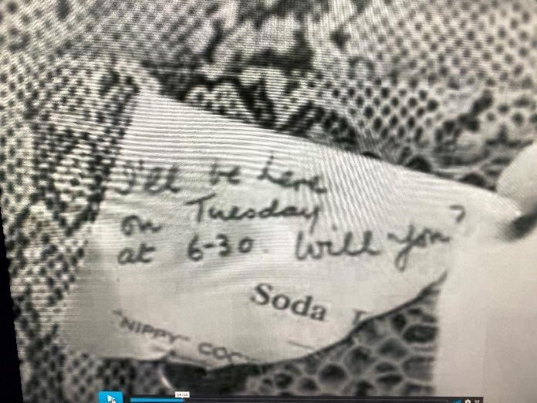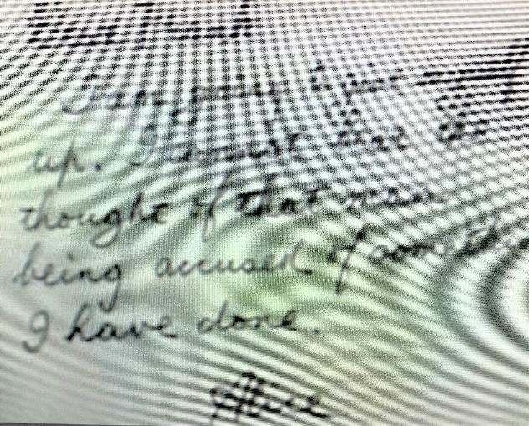
Here are some additional point-of-view shots from the film. What do you feel the person whose point of view these are might be feeling at the time?
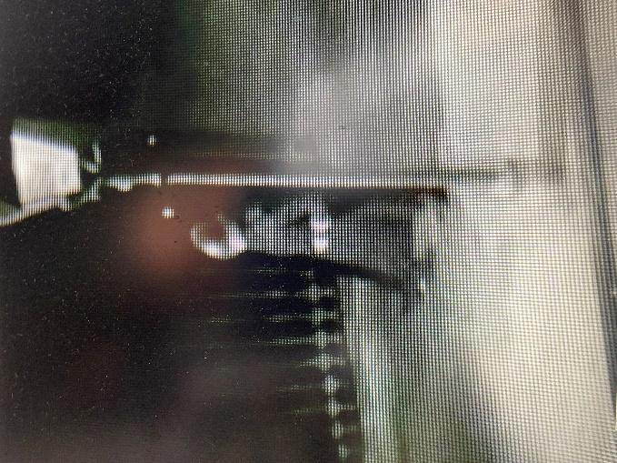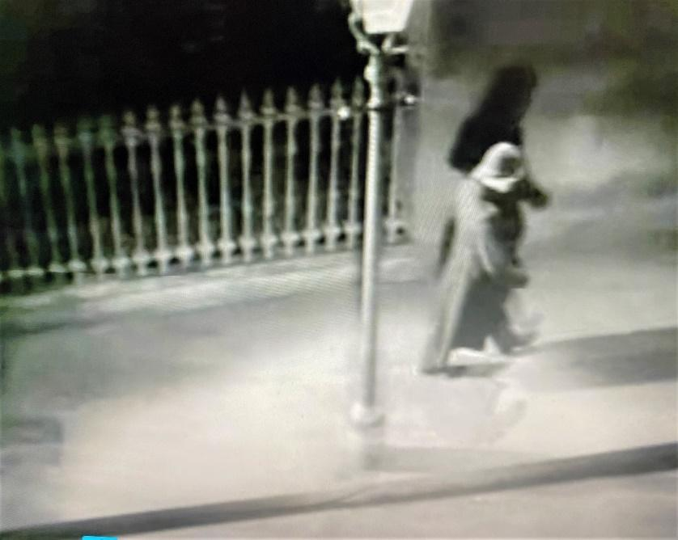
(21.29) Annie White watching the policeman on patrol from the window of the Artist’s studio soon after she gets there. (While it is not a point-of-view shot, the second high-angle shot of the policeman passing in the street outside the Artist’s studio at 32.30 has a completely different sub-text meaning given Alice’s unheeded cries and what is happening to her. This is included here to underline just how subtle a film-maker Hitchcock is: capable of having two such similar shots carry such different implications.)
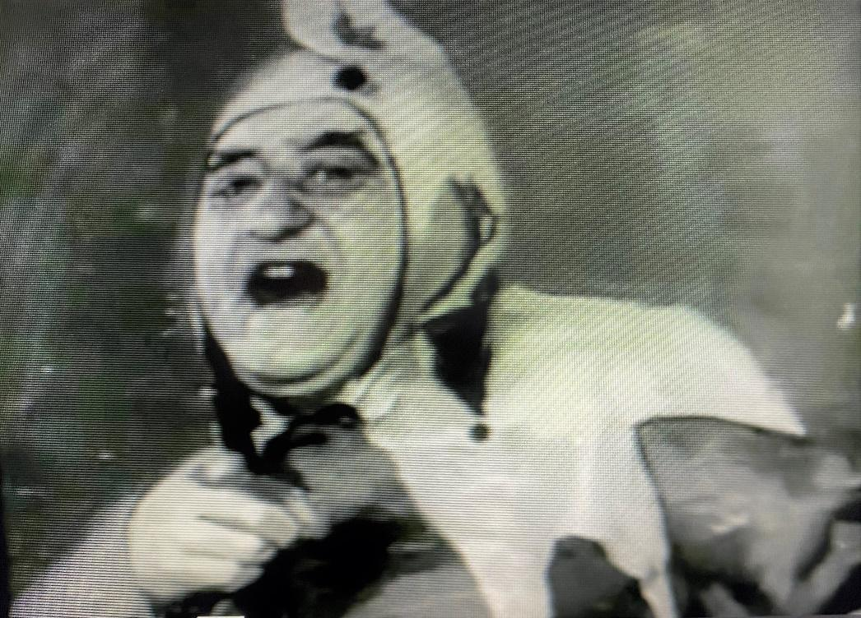
(22.05) This is the first point-of-view shot of the Jester painting. It is Alice’s point-of-view again that we share. Each time we see the Jester through Alice’s eyes and each time its impact on her is different. As you watch the film look out for those moments when the Jester picture is seen: make a note of whose eyes we are looking at it through and what it might mean to them at that moment.

Activity 4: Happy Ever After?
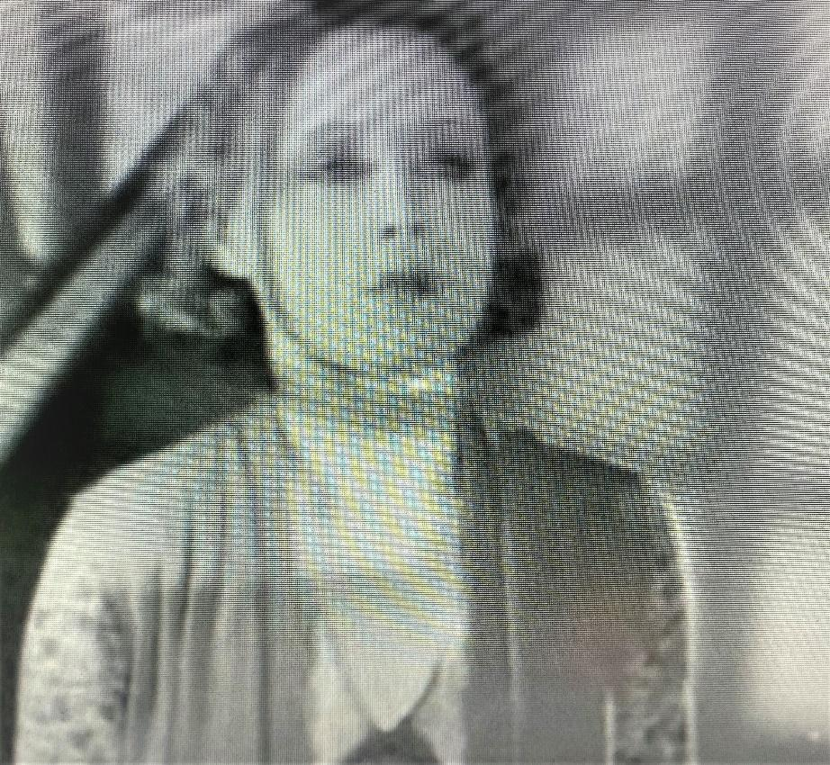 (1.18.18)
It is well worth watching Blackmail several times. You will spot new details, new patterns, and new ironies each time. For example, study this image of Alice just after she has resolved to go to the police station to confess. Notice the shadows – what do they resemble – both those on the wall and the one thrown onto her face and neck.
Activity 6: Publicising The Film
Here are two examples of printed publicity material associated with Blackmail. The first is a ‘window card’ placed usually in a cinema to promote the film, the other is a larger poster. What similar and different techniques do these two rare items employ to promote the film?
Use your artistic and copy-writing skills to design your own window card or poster. Remember to include as much the information you can. Use the copy on the poster to help you.
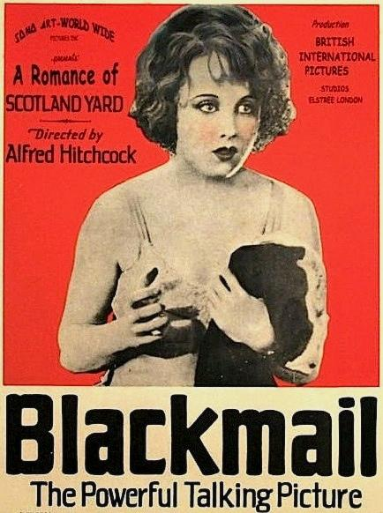

U.S. moviehouse window card for the motion picture Blackmail (1929), directed by Alfred Hitchcock, featuring star Anny Ondra

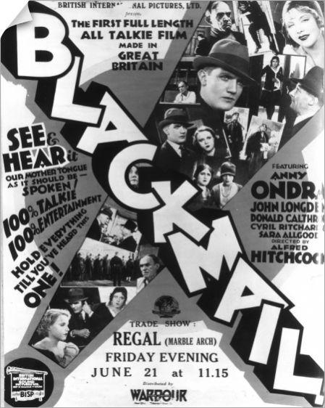

Blackmail Test Take (1929) - Alfred Hitchcock | BFI - YouTube

